Adrian Turion |  | Avenue de Sainte-Clotilde 9  1205 Geneva, Switzerland | 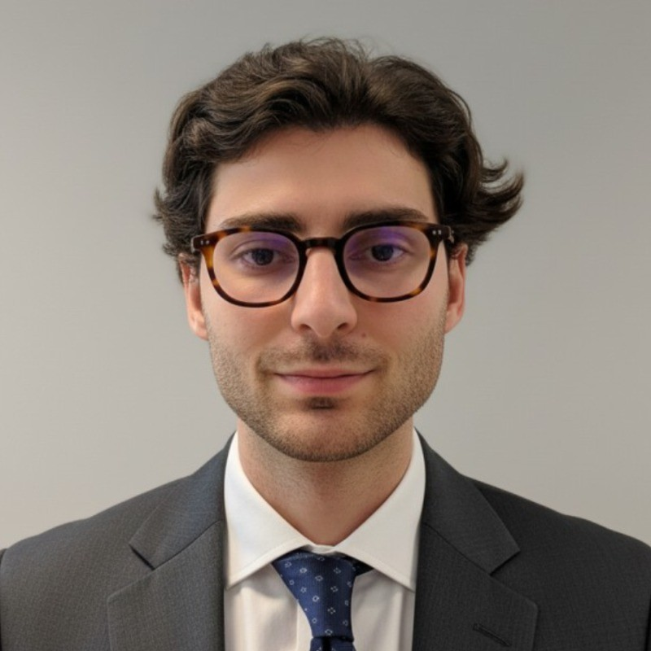
turionadrian@gmail.com | Swiss national | 10.11.2000 |  | +41 77 262 37 96
INTRODUCTION
M&A analyst with cross-border small & mid-cap deal experience and a strong focus on financial modelling and valuation, advising healthcare, tech and industrial companies across Europe and eager to contribute to Roche’s external growth strategy in Pharma, Diagnostics and Healthcare IT.
WORK EXPERIENCE
Auraïa Capital Advisory – Small & Mid Cap Cross-border M&A Boutique  Mergers & Acquisitions Analyst (Converted internship into full-time position) |  | Geneva, Switzerland  Aug 2024 – Current
- Execute small & mid-cap M&A and fundraising mandates in French-speaking Switzerland and Europe (sell-side, buy-side), with a strong focus on healthcare, tech & software, services and industrials, from initial screening and strategic review through to SPA negotiations
- Build integrated financial models and valuation outputs (DCF, LBO, trading & transaction comparables, scenario and sensitivity analysis) used in investment committees and board presentations, and support due diligence workstreams, data room preparation and information memorandums
- Structure data- and AI-driven target and buyer screenings by automating market mappings, public data gathering and CRM-based tracking, improving the depth and quality of M&A landscapes and outreach to potential counterparties

RC Group – Currently under LBO with Crédit Mutuel Equity  Mergers & Acquisitions Intern |  | Paris, France  Feb 2024 – Aug 2024
- Supported the CEO of the Healthcare & Retail division on a cross-border buy-and-build strategy, leading target screening and management discussions for 180+ companies and contributing to financial analyses and investment memos that underpinned advanced negotiations with shortlisted acquisitions

Europ Assistance – Subsidiary of Generali Insurance  Financial Analyst Intern |  | Geneva, Switzerland  Apr 2023 – Aug 2023
- Built P&L models and three-year forecasts across 27 B2B contracts (~CHF 20m revenues), supporting the CFO on budgeting, scenario analysis and strategic initiatives, and preparing concise materials for management committees

LEADERSHIP
- Finalist – Keyrock x McKinsey 2024: co-developed a quantitative model using order book and market data to forecast disruption scenarios and presented strategic recommendations under time pressure to Keyrock leadership and McKinsey partners
- Associate – AIESEC: relaunched post-COVID business development by sourcing corporate leads, producing tailored pitchbooks and negotiating three partnerships (~CHF 60k), significantly increasing volunteer placements
EDUCATION
HEC Lausanne  Master of Science in Finance |  | Lausanne, Switzerland  2021 – 2024
- Cumulative GPA: 5.2/6.0 (Top 15% of the class cohort)
- Exchange programs at Waseda University (Tokyo, Japan) and Maastricht University (Maastricht, Netherlands)
- Relevant Coursework: Corporate Finance, Valuation, M&A, Private Equity, Venture Capital
- Thesis Topic: Synergies Analysis of the Merger between American Airlines & US Airways

Bachelor of Science in Management |  | 2018 – 2021
- Cumulative GPA: 4.7/6.0

Scientific Baccalaureate (French National Baccalauréat) - Highest Honors (16.6/20) |  | Aix-en-Provence, France
ADDITIONAL INFORMATION
Languages:  Computer:  Interests:  References: | French (Native, C2), Spanish (Native, C2), English (Fluent, C1) German: Business proficient (B2–C1)  Excel, PowerPoint, Macabacus, FactSet, Capital IQ, Bloomberg, VBA, AI workflows & automations  Geopolitics, Badminton (Provence regional finalist), Gym, Real use cases of Artificial Intelligence  Guillaume Arnaldez – Ex-Director at Auraïa Capital Advisory, guillaume.arnaldez@auraia.ch

